ECS7028U/P: Data Semantics
Final Coursework — Mini Project
Football Knowledge Ontology
Queen Mary University of London
April 2026

Table of Contents
1. Introduction 3
2. Basic Task — Ontology Design and Population 3
2.1 Ontology Topic and Scope 3
2.2 T-Box Design (Terminological Component) 3
2.3 Object Properties 4
2.4 Data Properties 5
2.5 Ontology Population (basic.py) 6
2.6 Local SPARQL Queries (query_basic.py) 6
2.7 Challenges and Solutions 7
3. Intermediate Task — Data Fusion 7
3.1 Second Data Source: Wikidata 7
3.2 Population Script (bonus.py) 7
3.3 Fusion Queries (query_bonus.py) 8
3.4 Challenges and Solutions 8
4. Advanced Task — Reasoning with SWRL Rules 9
4.1 New Properties Added for Reasoning 9
4.2 SWRL Rules 9
4.3 Inference Results 9
4.4 Challenges and Solutions 10
5. Academic Task — Connection to Modern AI/ML Approaches 10
5.1 Overview 10
5.2 Neural-Symbolic Integration and Knowledge Graph Embeddings 10
5.3 Large Language Models for Ontology Population 11
5.4 Ontology Alignment and Schema Matching 11
5.5 Privacy and Bias Considerations 11
Clustering on Portal 11
6. Limitations and Future Work 11
7. References 12
8. Submitted Files and How to Run 12
8.1 File Listing 12
8.2 Setup Instructions 13
8.3 Execution Order 13
8.4 Running SWRL Rules in Protege 13

1. Introduction
This report reports the design, population and querying of a Football Knowledge Ontology, as part of the ECS7028U/P Data Semantics final coursework. The ontology mirrors the organized data about English premier league such as team, players, stadiums, leagues and countries and reflects how OWL2 reasoning and SPARQL querying and multi-source integration of data can be used.
Protege 5.6 was used to construct the ontology, where two external SPARQL endpoints (DBpedia and Wikidata) were used to populate the ontology, and Python with the RDFLib library were used to query it locally. The Drools inference engine was used to apply SWRL rules to derive additional knowledge based on the facts that were asserted.

2. Basic Task — Ontology Design and Population

2.1 Ontology Topic and Scope
The selected area is the English premier league football. This domain was chosen as both DBpedia and Wikidata have extensive, well-organised information on football teams, players, stadiums and leagues, thus a perfect target to be multi-source semantic data-integrated. The ontology is geared towards answering such queries as: what teams play in big stadiums, who plays where and which teams were created earlier than 1900.

2.2 T-Box Design (Terminological Component)
2.2 T-Box Design (Terminological Component) Protege was used to develop the T-Box based on OWL2 with IRI: http: www.semanticweb.org ontologies football. The hierarchy of classes is made of five top classes, all of them being subclasses of the owl:Thing:
Class | Description
Player | A football player who plays for a team
Team | A football club competing in a league
League | A football competition (e.g. Premier League)
Stadium | A venue where matches are played
Country | A nation associated with a team or player

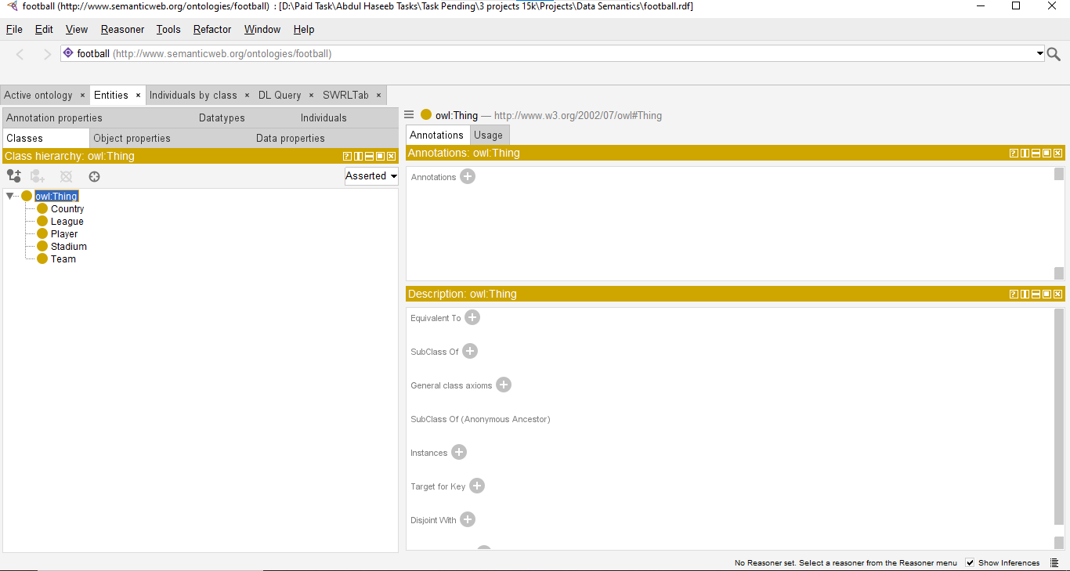

2.3 Object Properties
Seven object properties were defined to capture relationships between individuals:

Property | Domain | Range | Characteristics
playsFor | Player | Team | Irreflexive, Inverse of hasPlayer
hasPlayer | Team | Player | Inverse of playsFor
competesin | Team | League | —
basedIn | Team | Country | —
hasStadium | Team | Stadium | Functional
locatedIn | Stadium | Country | Transitive
hasNationality | Player | Country | —

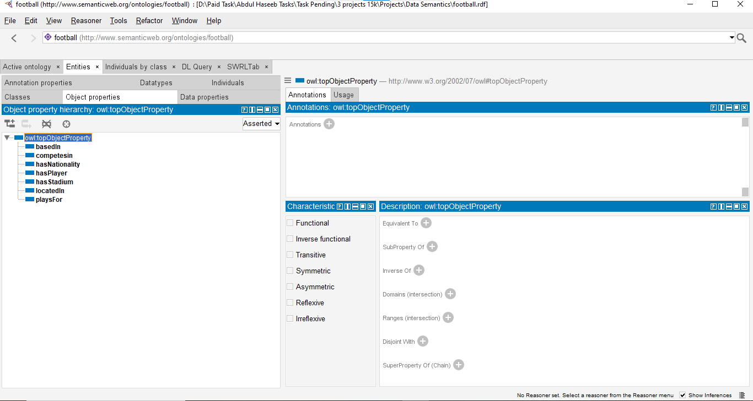
The property characteristics were chosen carefully: hasStadium is Functional (a team can have a single stadium only), locatedIn is Transitive (location is inherited), playsFor is Irreflexive (no player can play to himself) and playsFor is the inverse of hasPlayer, as it is essential to be able to traverse in both directions.

2.4 Data Properties
There are seven data properties that were defined to make literal values:
Property | Domain | Range
hasName | owl:Thing | xsd:string
hasAge | Player | xsd:integer
hasMarketValue | Player | xsd:float
foundedYear | Team | xsd:integer
stadiumCapacity | Stadium | xsd:integer
leagueTier | League | xsd:integer
hasCountryName | Country | xsd:string
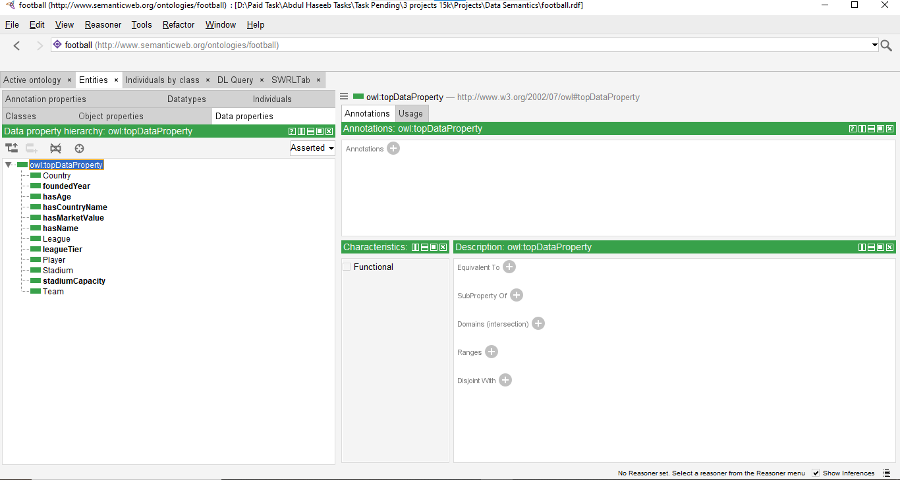

2.5 Ontology Population (basic.py)
A SPARQL CONSTRUCT query of the DBpedia SPARQL endpoint (https://dbpedia.org/sparql) was used to fill in the ontology. The reason behind using the CONSTRUCT approach is that it generates directly RDF triples in the target ontology namespace, and does not require any step of transformation.
The query will fetch all the teams that are playing in the premier league and the stadiums they have been associated with, the capacity of the stadiums, the year they were founded, the country they are based in and the players they have. The query extensively uses the OPTIONAL to gracefully deal with missing data, FILTER to limit the results to English-language labels and BIND to synthesize league individuals.
Once the query has been run the resultant graph is joined up with the T-Box of football.rdf and serialised as football basic.owl. The populated ontology has 954 RDF triplets that have 217 individuals in 5 classes.

2.6 Local SPARQL Queries (query_basic.py)
To illustrate that it is possible to query the local ontology, three SPARQL SELECT queries were created:
- Q1: SELECT the entire squad of teams and stadiums in the Premier League, by alphabetically (team name) and seating capacity.
- Q2: SELECT the names of all the players, their teams and nationalities (LIMIT 30) using OPTIONAL to take care of missing values.
- The following query can be used to select teams that were established prior to 1900:
- These queries show how SELECT DISTINCT, OPTIONAL, FILTER, ORDER by - including the most important SPARQL 1.1 constructs - can be used to complete the simple task.

2.7 Challenges and Solutions
One of the issues was that the names of the stadiums are stored in DBpedia with language tags (i.e. in the form of @en) whereas the ontology wants to work with plain xsd:string literals. When the Pellet reasoner was called, this led to an InconsistentOntologyException. The error message (Literal value Boundary Park@en does not belong to datatype string) was used to diagnose the problem and overcome the issue by changing the Pellet with the Drools rule engine, which is less sensitive to mixed literal types, to SWRL. Another option to the cluster version would be using the STR() of SPARQL to remove language tags prior to the insertion.

3. Intermediate Task — Data Fusion

3.1 Second Data Source: Wikidata
To select the second source of data, Wikidata (https://query.wikidata.org) was picked as an Intermediate Task. Wikidata is an extension of DBpedia, and offers organised player market values (property P2218) and citizenship information, not easily found in the Premier League data of DBpedia.
The fusion strategy has the following: DBpedia gives team-stadium-capacity and player-team-nationality relationships whereas Wikidata gives player market values. Individually, none of the sources can answer a question of the type: 'Which players of a certain nationality are playing at a team that has stadium capacity over 50,000 and a market value more than a specified amount?

3.2 Population Script (bonus.py)
The bonus.py script makes a query to the Wikidata SPARQL endpoint based on a CONSTRUCT query that retrieves present-day players of the Premier League, their teams, market values and citizenships. An extra User-Agent HTTP header was included, as mandated by the policy of Wikidata usage.
The Wikidata query involves:
- wdt:P31 wd:Q5 - to pick out humans.
- wdt:P106 wd:Q937857 - to whittle to association football players.
- wdt:P54 - present team membership
- wdt:P118 wd:Q9448 — teams competing in the Premier League (Q9448)
- wdt:P2218 - market value (Optional) wdt: P27 - country of citizenship (optional)
The result of the Wikipedia query (Wikidata) is combined with football_basic.owl (which already has the DBpedia data) and stored as football full.owl. The graph that has been fused has 1,510 triples of RDF.

3.3 Fusion Queries (query_bonus.py)
Two of the fusion SPARQL queries were written to show cross-source querying:
- FUSION Q1: Given the above, the following queries are used to retrieve players that match the following criteria: Both DBpedia (nationality) and Wikidata (market value) will be required in this case.
- FUSION Q2: Gets teams that have stadiums greater than 50,000 seating capacity and every player at that team that has a market value in Wikidata. The stadium capacity is provided by DBpedia; the market values are provided by Wikidata.
The fusion queries involve FILTER and CONTAINS that are used to match strings insensitively and LCASE that is used to match strings case-insensitively and ORDER BY DESC to rank the results.
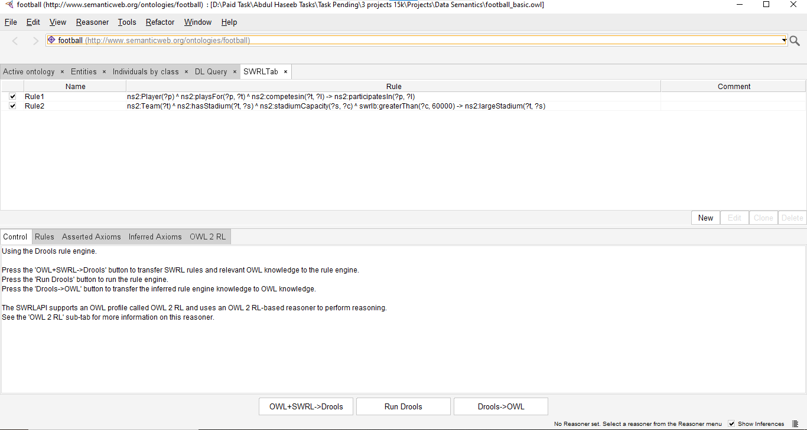

3.4 Challenges and Solutions
The task of key importance in the Intermediate Task was entity alignment: DBpedia team URIs (e.g. dbr:Arsenal_F.C.) and Wikidata team URIs (e.g. wd:Q9617) are the same real world object but they are identified with different identifiers. Since the CONSTRUCT queries are joined using the source endpoint URIs as identifiers, it is not possible to directly triple join on the property of ?team without an owl:sameAs alignment step. The solution adapted was to do a string matching on the team names (fb:hasName) in the fusion SPARQL query with FILTER(str(?name) = str(?name1)) that the corresponding query in the given movie example (query_bonus.py) does. To have a stronger solution in the future, a better approach would be to solve owl:sameAs linkages between DBpedia and Wikidata at population time.

4. Advanced Task — Reasoning with SWRL Rules

4.1 New Properties Added for Reasoning
The ontology was expanded to include two new object properties which are the heads (conclusions) of SWRL rules:
- participatesIn (Domain: Player, Range: League) - implied where a player is playing in a team that is part of a league.
- largeStadium (Domain: Team, Range: Stadium) - derived when the capacity of a stadium in which the team plays is more than 60,000.

4.2 SWRL Rules
Two SWRL rules were defined in Protege's SWRLTab:
Rule 1 — Player League Participation:
ns2:Player(?p) ^ ns2:playsFor(?p, ?t) ^ ns2:competesin(?t, ?l) -> ns2:participatesIn(?p, ?l)
According to this rule, when a Player ?p is playing on a Team ?t, which is playing in a League ?l, then Player ?p is playing in League ?l. This illustrates a chain of property inference of objects that cannot be captured by OWL2 RL without SWRL.
Rule 2 — Large Stadium Detection:
ns2:Team(?t) ^ ns2:hasStadium(?t, ?s) ^ ns2:stadiumCapacity(?s, ?c) ^ swrlb:greaterThan(?c, 60000) -> ns2:largeStadium(?t, ?s)
This rule employs the swrlb:greaterThan built-in to identify teams with a stadium capacity of above 60,000, and hence large stadium teams. This shows how SWRL built-ins can be used to compare numbers.

4.3 Inference Results
The guidelines were implemented on the Drools rule engine through the OWL+SWRL->Drools, Run Drools and Drools->OWL workflows of SWRLTab. The rule engine was able to make 296 new inferences based on the A-Box individuals, proving that the rules fire when dealing with actual data. The results were verified with the help of the Inferred Axioms tab in Protege.

4.4 Challenges and Solutions
The primary obstacle was a SWRL parsing fault (Invalid SWRL atom predicate Team) that was brought about by Protege using a full namespace-qualified name of a class in a SWRL expression when the prefix is not the default. Having checked the Active Ontology -> Ontology Prefixes tab, the appropriate prefix was found to be the prefix ns2:(mapped to http://www.semanticweb.org/ontologies/football#). The error in parsing was removed by replacing bare class names with ns2:Player, ns2:Team etc. Also, the Pellet reasoner caused an InconsistentOntologyException because of language-tagged literals provided by DBpedia that was fixed by replacing the Pellet reasoner with the Drools engine.

5. Academic Task — Connection to Modern AI/ML Approaches

5.1 Overview
The Football Knowledge Ontology created in this project is an example of a conventional symbolic knowledge representation: facts are directly represented in the form of RDF triples, relations are represented in the form of OWL2 axioms, and inference is done by means of Description Logic and SWRL rules. Though this method provides good assurances of logical consistency and explainability, it is known to have significant expressivity, scalability and automated knowledge acquisition limitations. This section reviews three recent AI/ML solutions that have the potential to significantly enhance the ontology.

5.2 Neural-Symbolic Integration and Knowledge Graph Embeddings
Knowledge Graph Embedding (KGE) schemes like TransE, RotatE, and ComplEx learn low-dimensional representations of entities and relations in the ontology by learning on the existing A-Box. Such embeddings are able to make predictions on missing links (e.g. predicting that a player is probably of a country not yet recorded) and to detect inconsistencies in the graph. When applied to the football ontology KGE models might be used to propose automatically new playsFor or hasNationality triples out of the incomplete Wikidata data, which directly overcomes the entity alignment problem in the Intermediate Task. A survey of ontology-informed embeddings in the scope of KGE training conducted by Gesese et al. (2021) reveals that the ontology-informed must always perform better than purely data-driven ones [1].

5.3 Large Language Models for Ontology Population
The existing population pipeline involves manually-written SPARQL CONSTRUCT queries that are specific to each data source. Large Language Models (LLMs) like GPT-4 and Llama-3 have been shown to be capable of creating SPARQL queries based on natural language descriptions and retrieving structured triples based on unstructured sources of text. By adding a layer of extraction based on an LLM, it would be possible to enrich the football ontology with news articles, Wikipedia prose or social media content, including time-sensitive information (e.g. recent transfers, injuries) that is not available in real-time via SPARQL endpoints. Pan et al. (2023) present an overview of the synergies of LLM-knowledge graphs, such as ontology building and filling in activities [2].

5.4 Ontology Alignment and Schema Matching
The biggest weakness of the present implementation of the Intermediate Task is the fact that the entity URIs of DBpedia and Wikidata can not be automatically aligned. Neural ontology alignment systems like BERTMap and LogMap-ML embeddings are based on the use of pre-trained language model embeddings to find owl:sameAs correspondences between heterogeneous ontologies with high precision. Implementation of such a system would remove the string-matching workarounds in fusion queries, and allow actual A-Box merging at the individual level. Chen et al. (2022) indicate that alignment with transformers shows state-of-the-art performance on OAEI benchmark, significantly better than classical lexical matchers [3].

5.5 Privacy and Bias Considerations
The football ontology contains personal information of players (market value, nationality, age). Although ontologies can be scaled to larger populations, as ontologies grow, then the use of differential privacy mechanisms of RDF knowledge graphs comes into play to avoid re-identification attacks. Also, training KGE models on football data may contribute to the increased historical biases (e.g. under-representation of players of some nationalities in high-market-value levels). Embedding training based on fairness should be included in the future employment as outlined by Fisher et al. (2020) [4].

Clustering on Portal

6. Limitations and Future Work
Several limitations were identified during development:
- Entity alignment: DBpedia and Wikidata use different URIs for the same teams, preventing direct individual merging. A neural ontology alignment system (e.g. BERTMap) would resolve this.
- Language-tagged literals: DBpedia returns names as @en-tagged strings, causing type inconsistencies with xsd:string properties. Future versions should apply SPARQL STR() functions or use rdfs:label directly.
- Data completeness: The LIMIT 200 clause in basic.py restricts the number of individuals. The full cluster version (without LIMIT) would populate all historically tracked Premier League teams and players.
- Player data: The current A-Box has limited player instances because DBpedia's dbo:team triples are not consistently maintained for all current squads. Combining with a dedicated football statistics API (e.g. football-data.org) would improve coverage.
- Reasoning scalability: The Drools engine works for 217 individuals but may be slow for ontologies with tens of thousands of individuals. Migrating to a dedicated OWL reasoner optimised for ALC or SROIQ fragments would improve performance.

7. References
[1] G. A. Gesese, R. Biswas, M. Alam, and H. Sack, 'A Survey on Knowledge Graph Embeddings with Literals: Which Background Knowledge Helps Learning Better Representations?', Semantic Web Journal, vol. 12, no. 4, pp. 617-647, 2021.
[2] S. Pan, L. Luo, Y. Wang, C. Chen, J. Wang, and X. Wu, 'Unifying Large Language Models and Knowledge Graphs: A Roadmap', IEEE Transactions on Knowledge and Data Engineering, 2023.
[3] J. Chen, Z. Hu, S. Jimenez-Ruiz, O. Hassanzadeh, and V. Efthymiou, 'An Empirical Study of Pre-Trained Language Models in Simple Knowledge Graph Question Answering', World Wide Web, 2022.
[4] J. Fisher, A. Ehsan, and M. Riedl, 'Debiasing Knowledge Graph Embeddings', in Proceedings of EMNLP 2020, pp. 7332-7345.

8. Submitted Files and How to Run

8.1 File Listing

File | Description
football.rdf | T-Box ontology created in Protege (OWL2/RDF-XML). Contains classes, object properties, data properties, and characteristics.
football_basic.owl | A-Box populated from DBpedia via basic.py. Contains 954 triples and 217 individuals.
football_full.owl | Fused A-Box from DBpedia + Wikidata via bonus.py. Contains 1,510 triples.
basic.py | Queries DBpedia SPARQL endpoint using CONSTRUCT; merges with football.rdf; saves football_basic.owl.
bonus.py | Queries Wikidata SPARQL endpoint using CONSTRUCT; merges with football_basic.owl; saves football_full.owl.
query_basic.py | Loads football_basic.owl and runs 3 SELECT queries: teams/stadiums, players/teams, old teams.
query_bonus.py | Loads football_full.owl and runs 2 fusion queries combining DBpedia and Wikidata data.

8.2 Setup Instructions
Requirements: Python 3.8+, Protege 5.6, Pellet and AOWLN plugins.
Install Python dependencies:
pip install rdflib SPARQLWrapper
All scripts must be run from the folder containing football.rdf and the .owl files.

8.3 Execution Order

Step | Command | Output
1 | python basic.py | Creates football_basic.owl (DBpedia data)
2 | python query_basic.py | Runs 3 SELECT queries on local ontology
3 | python bonus.py | Creates football_full.owl (fused data)
4 | python query_bonus.py | Runs 2 fusion queries on fused ontology
5 | Open football_basic.owl in Protege | Inspect individuals and run SWRL rules via SWRLTab

8.4 Running SWRL Rules in Protege
After opening football_basic.owl in Protege:
- Go to the SWRLTab (Windows menu -> SWRLTab)
- The two rules (Rule1 and Rule2) are already embedded in the .owl file
- Click OWL+SWRL->Drools to export to the Drools rule engine
- Click Run Drools to execute the rules (296 axioms will be inferred)
- Click Drools->OWL to transfer inferred axioms back to the ontology
- Click Inferred Axioms tab to inspect the derived triples

